Skyline Ridge 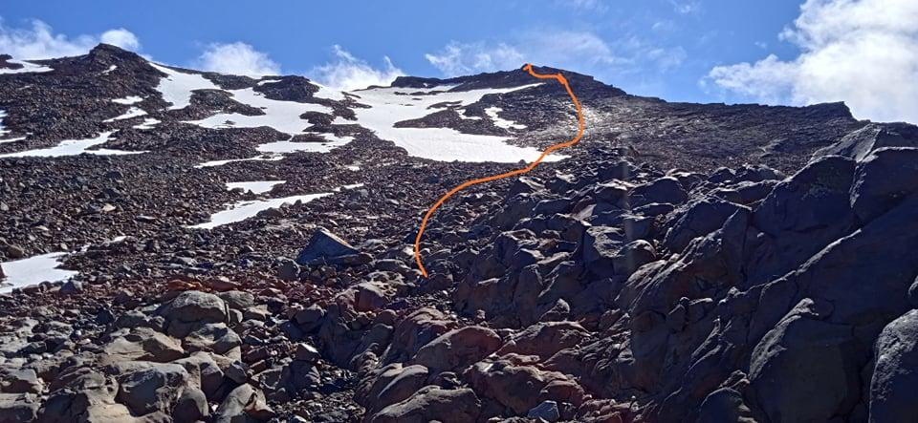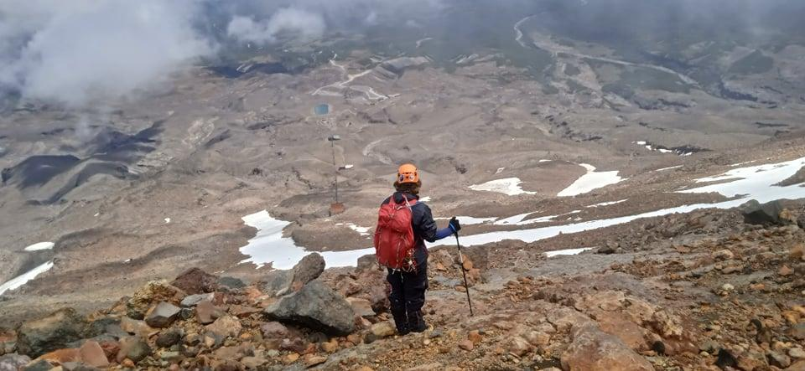

29/01/21

Written by Laura

Ft. Laura Jacks and Jason Rosinger

The trip started as most alpine trips do. We looked at the weather, said “lets do it”, and posted on the Snow School Graduates Facebook Page the night before. The idea was to cram in my first summit to the highest point of Ruapehu, right before we were due to meet up with a group of friends in the Ruahine ranges. We headed down in the evening, so we would be able get a few hours sleep before summiting the next day.

The conditions were perfect, which allowed us plenty of time for me to slowly get up, testing my nepals on slab for the first time. Everything went smoothly and according to the plan. It was a blue bird day and the rock was lovely. As we neared the ski lifts we stopped in briefly to say hi to the repair guys and enjoy the great music they were blasting through the speakers. Around the same area we also found evidence that someone else had stopped to *enjoy the view*, in the form of a rusty old nang cracker. We continued on and only needed crampons once, for the single band of ice you’ll find on the mountain in mid-summer. The top few hundred metres are noticeably steeper and provide some pleasant “choose your own adventure” scrambling. Eventually you veer left, up the final ridgeline traverse that takes you round the rim of the ice plateau to the summit. However, you would be mistaken if you were expecting a view. It wouldn’t be Ruapehu without it’s classically thick white fog that shrouds its peaks. This reputation remained untarnished on our journey too. 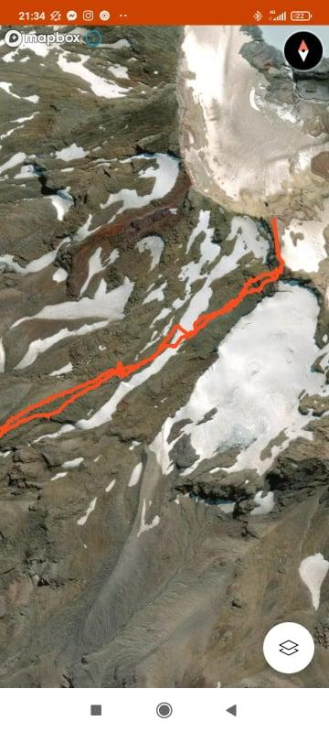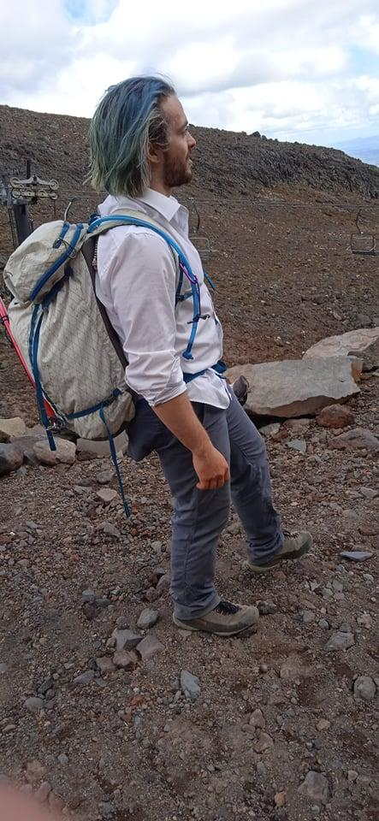

All in all it was a nice day trip that I would recommend to any snow school graduates that are looking to dip their toes in. 